CSE321 Project 1

# Part 3:

IDE Overview

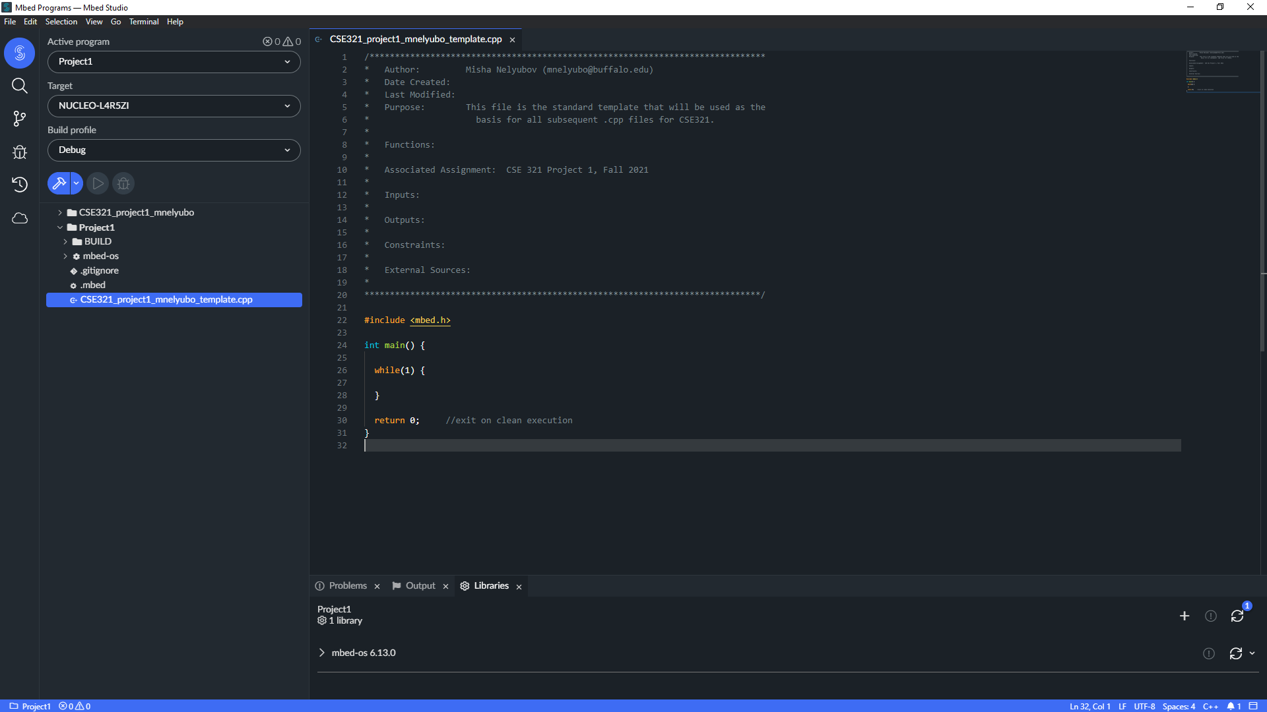

Project Tree:

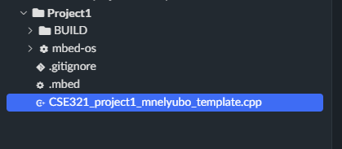

Standard Template with header:

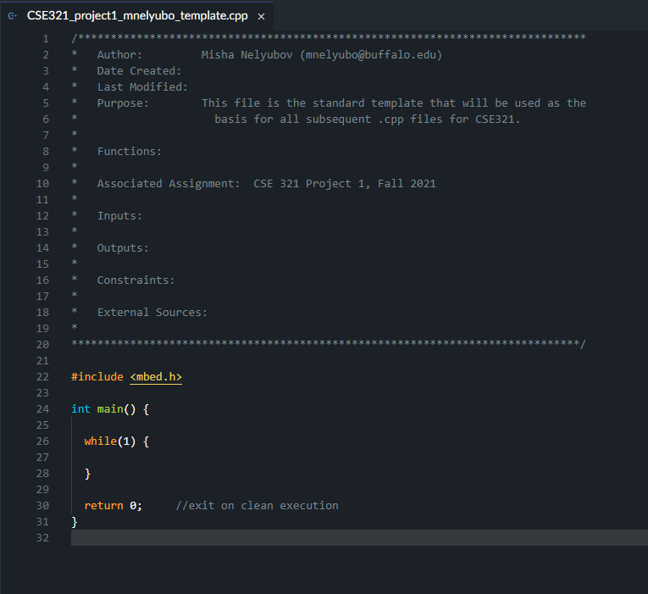

# Part 4: GitHub

Account Name: MSNelyubov

Repository URL: https://github.com/CSE321-Fall2021/cse321-portfolio-MSNelyubov/tree/main